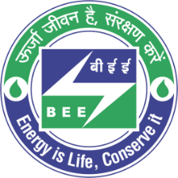 | BUREAU OF ENERGY EFFICIENCY (BEE)  (A Statutory body under Ministry of Power, Govt. of India)  4th Floor, Sewa Bhawan, R. K. Puram, New Delhi - 110066
Hiring of Technical Professionals for GEF-UNDP Project on Energy Efficiency and Thermal Comfort in Buildings (EETCB)
Date: 15th October, 2025

Bureau of Energy Efficiency (BEE) intends to engage “Project Manager, Senior Sector Experts (Building Energy Efficiency) and Senior Sector Expert (Low-carbon comfort systems)” purely on contract basis to provide technical support for Energy Efficiency and Thermal Comfort in Buildings (EETCB) project.
The engagement shall be for a period of two years which is extendable on annual basis subject to satisfactory performance based on KPIs of the individual and requirement of the project.
The interested applicants fulfilling the eligibility criteria may forward their curriculum vitae (CV) in prescribed format, within 30 days from the date of publication in Employment News, to the office of the “Director (Building), Bureau of Energy Efficiency (BEE), 4th Floor, Sewa Bhawan, R. K. Puram, Sector-1, New Delhi-110066”.
The details of positions, Educational Qualification, Age and professional Experience etc., can be downloaded from the website of Bureau of Energy Efficiency (www.beeindia.gov.in).

Director, BEE

